**Problem Statement:**

You have successfully cleared the first semester. In your second semester youwill learn how to create tables, work with WHERE clause and basic operators.

**Task to be Performed:**

1. Create a customer table which comprises of these columns: ‘customer_id’, ‘first_name’, ‘last_name’, ‘email’, ‘address’, ‘city’,’state’,’zip’.

* First Create table using Create Table command then insert columns names in round brackets

**Snippet:**

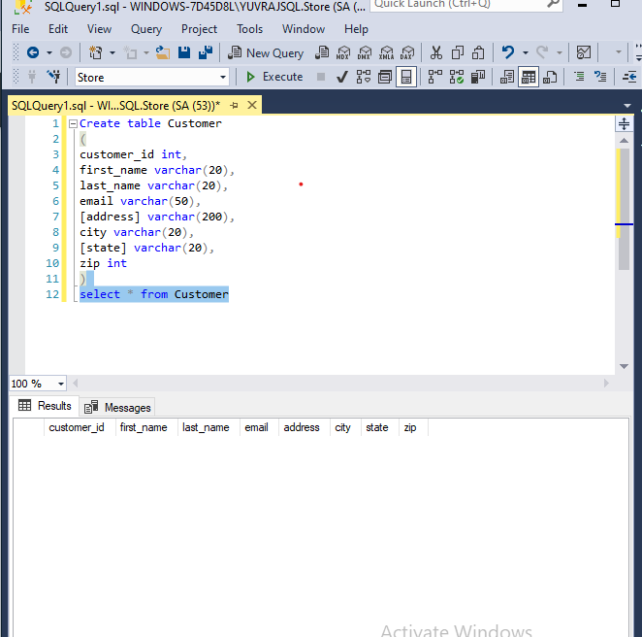

2 . Insert 5 new records into the table

-Used insert command to select columns where I want to insert Data.

-To show Table I used select command with “*” for whole record.

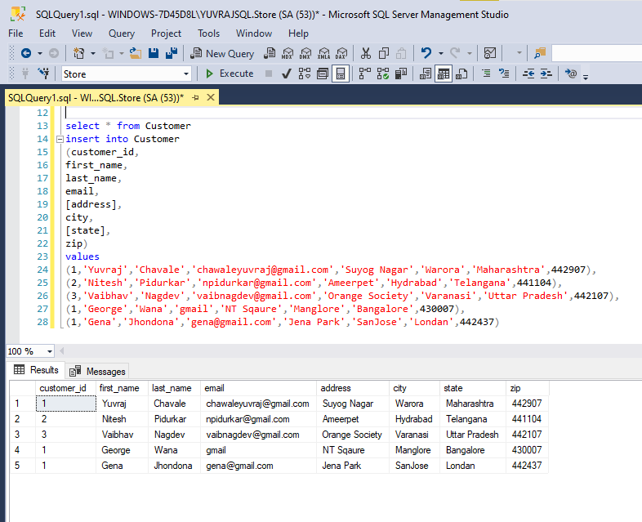

1. Select only the ‘first_name’ and ‘last_name’ columns from the customer table.

* To Show particular columns we use select command with columns name from which table,

**Snippet:**

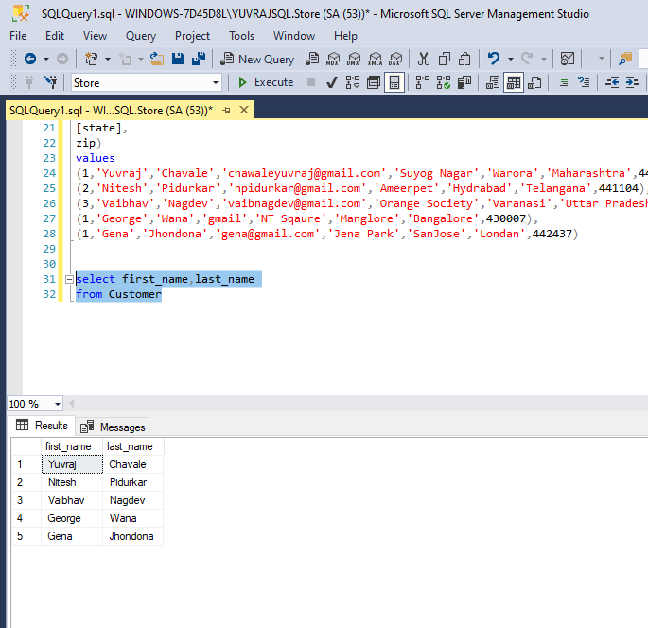

1. Select those records where ‘first_name’ starts with “G” and city is ‘SanJose’.

* Here I use Where clause to select from which columns.
* Then use’ Like’ & ‘And’ operator to check first letter with city name .

**Snippet:**

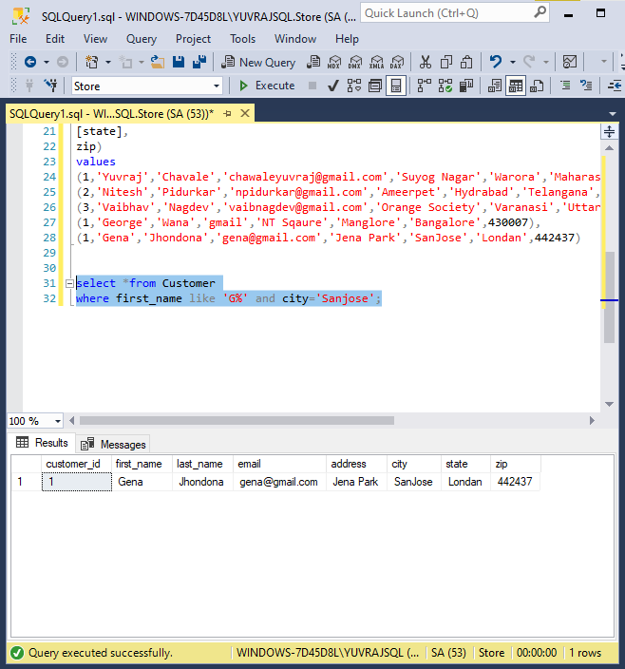

5. Select those records where Email has only ‘gmail’.

- Here I use where clause again to check email have only gmail word in column.

**Snippet:**

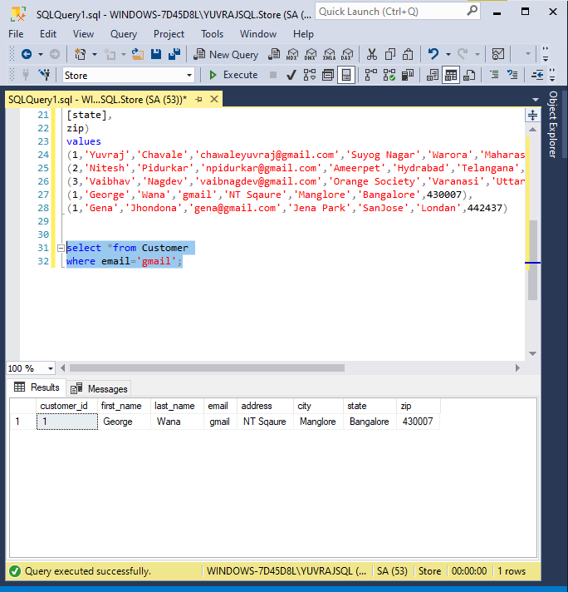

1. Select those records where the ‘last_name’ doesn't end with “A”.

* I use not like operator to fetch the data

**Snippet:**

